SOS: Systems of Data and the Organic Farm

Winter ‘25 Final Report DRAFT and Table of Contents

13 February 2025

[Shawn Bird](https://canvas.evergreen.edu/courses/7110/users/42240), [Hayden Edge](https://canvas.evergreen.edu/courses/7110/users/41378), [Leif Fischer](https://canvas.evergreen.edu/courses/7110/users/23003), [Ocean Greens](https://canvas.evergreen.edu/courses/7110/users/42464), [Jedidiah Haney](https://canvas.evergreen.edu/courses/7110/users/42116), [Daniel Kerry](https://canvas.evergreen.edu/courses/7110/users/42993), [Griffin Loiselle](https://canvas.evergreen.edu/courses/7110/users/30768), [Dani Monroe](https://canvas.evergreen.edu/courses/7110/users/35008), [Victoree Stevens](https://canvas.evergreen.edu/courses/7110/users/37710), [Austin Strayer](https://canvas.evergreen.edu/courses/7110/users/39384), [Dawson White](https://canvas.evergreen.edu/courses/7110/users/26646), [Willard Wiencken](https://canvas.evergreen.edu/courses/7110/users/36571)

Faculty:

[Melissa Nivala](https://canvas.evergreen.edu/courses/7110/users/15752), Paul Pham

Please add your name

Section 1: Introduction

# Section ??: Updated System Design Diagram

Start with project proposal and augment. Single-board computers in the wash station (ESP32 / Arduino, Barcode Scanner, Raspberry Pi), cloud computer servers (Digital Ocean)

# Section ??: Data Flow Diagram

What packets are being sent on each port to which IP address, what does a typical packet look like

Admin panel (data manipulation, like a database UI, what farm manager would use)

Like GrowFlow system that Ocean Greens has

# Section ??: Data Privacy

How / whether to store A numbers, FERPA concerns

We can hash PII (personally-identifiable information) to make deterministic but not correlatable.

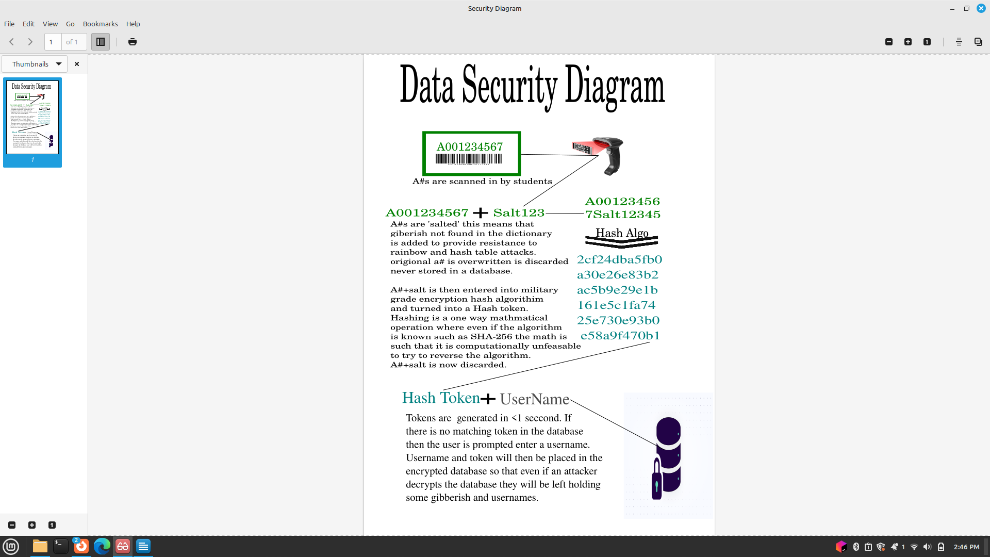

## Section ??: Data Analytics Dashboard

The data analytics dashboard processes collected data on metrics such as labor and harvest, presenting this information graphically. Guided by the principles outlined in the book Storytelling with Data: A Data Visualization Guide, the dashboard is designed to present information intuitively. This approach transforms administrative decision-making into a data-driven science, enabling users to make informed decisions based on clear, visual insights.

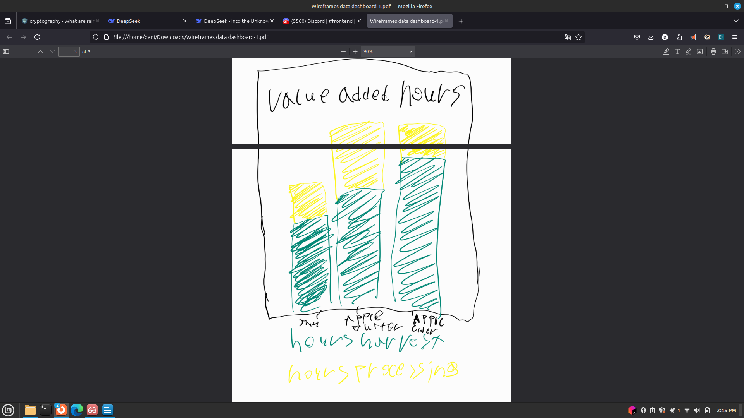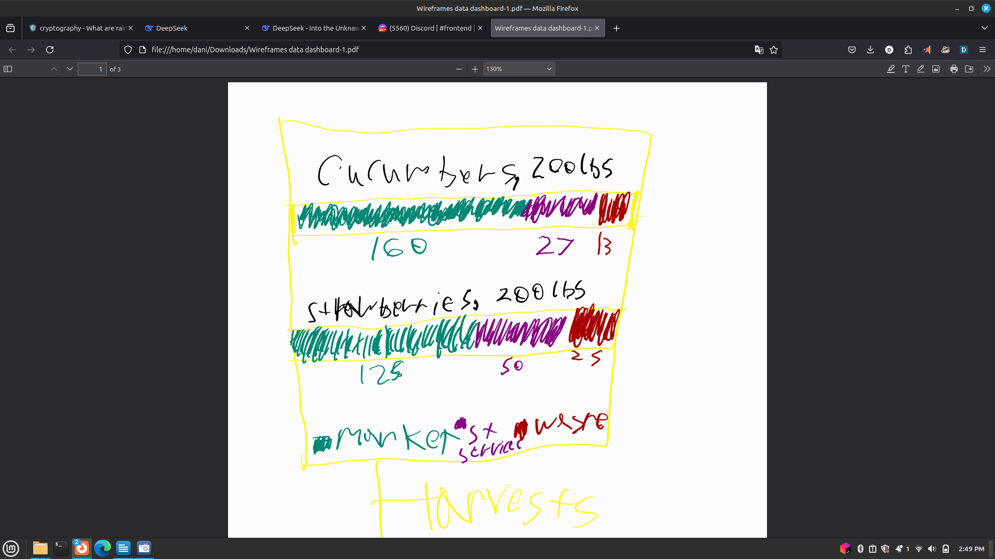

Section ??: Bluetooth Human Interface Device (HID) Plan Between ESP32 / Arduino and Raspberry Pi

Section ??: Arduino Weight Sensor and Scale

Section ??: Ocean Greens Automated Greenhouse Field Trip, Lessons for Evergreen’s Organic Farm Automation

# Section ??: Faculty Maintenance

What course catalog entry, credit descriptions, and credit requirements do faculty owe students?

What security audit should the faculty supervise the class in doing to present a quarterly report to IT / Academic Computing that security concerns are being met?

Nmap scans, iptables / ufw firewall rules

Section ??: Within Quarter Maintenance

[ Example: need ideas and feedback for this ]

Running apt update for Long-Term Support releases of Ubuntu / Debian on Raspberry pi

Monitoring security vulnerability reports for Arduino library